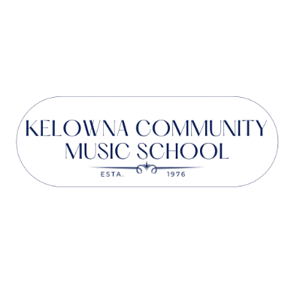
Registration 2022/23

This package includes:
- Registration form – Please complete one form per family. List each child and each lesson/group.
- Academic calendar – Your instructor will confirm your lesson dates directly with you. The KCMS office follows the School District 23 calendar (on the reverse). Visit our website for current calendar items.
- Policies – All KCMS policies are posted on our website. All families must review and complete our KCMS Policies and Consent Form prior to attending your first lesson.

Registration Fees:

Summer Private Lessons, Group Lessons, and Theory courses | $20.00
Annual Private Lessons for 1 student | $50.00
Annual Private Lessons for 2 or more students from the same family | $80.00
Note, Registration Fees for private lessons ONLY are pro-rated on January 1st and April 1st
Note: Summer Registration fees will be credited towards your Annual Registration fees
if you continue to take group, theory or private lessons September through June.

Registration Process:
- Confirm all lesson times for each student with your instructor(s).
- Review our KCMS Policies and Safety Plan on our website.
- Complete the Registration form attached or use our fillable form online. List ALL students and ALL lessons on one form. One form per family.
- Save the Registration form as a PDF and email to our office at: kelownacommunitymusicschool@shaw.ca.
- To secure your spot, send your Registration fee payment (amount listed above) with your registration form. We accept payment by cash, debit, cheque or etransfer to the email below. Etransfer confirmations will indicate the name of one of our signatories: Lucy Benwell, Samia Hasan, or Robert Payne. We cannot accept credit cards or credit debit cards at this time.
- Once we have confirmed your information, you will receive your KCMS Policies and Consent Form link. Completing this form ensures you have read our policies.
- Your spot is not guaranteed until the registration fees have been paid and you have completed the KCMS Policies and Consent Form.
- Lesson Fee Invoices for 2022/23 will be processed after August 14, 2022 advising you of the total cost and payment options.

Office hours: Monday 9am-5pm; Tues-Thurs 1-5pm
250-860-1737
Please phone prior to visiting to confirm summer office hours.
Win Back Your Registration Fee!!
All families who have paid their annual Registration Fee by 4:30pm, Thursday, July 14th
will be entered into a draw to win back their registration fees!
(Credit will be applied against annual fees for 2022/23. No cash value.)

PLEASE CONFIRM YOUR START DATE WITH EACH TEACHER.

Email: kelownacommunitymusicschool@shaw.ca or visit us online at www.kelownacommunitymusicschool.ca

2022-2023 KCMS Academic Calendar
 | Sun | Mon | Tues | Wed | Thurs | Fri | Sat
September |  |  |  |  | 1 | 2 | 3 | School begins  Sep 6  Truth & Reconciliation Day Sep 30  Closure TBC  Thanksgiving  Oct 10  Remembrance Day Nov 11  Christmas break  Dec 19-Jan 2  School reopens  Jan 3  BC Family Day  Feb 20 - SD23 closure TBC  Spring Break  Mar 20-Apr 2  Easter  Weekend  Apr 7-10  Victoria Day  May 22  SD23 Final day June 29
 | 4 | 5 | 6 | 7 | 8 | 9 | 10
 | 11 | 12 | 13 | 14 | 15 | 16 | 17
 | 18 | 19 | 20 | 21 | 22 | 23 | 24
 | 25 | 26 | 27 | 28 | 29 | 30
October |  |  |  |  |  |  | 1
 | 2 | 3 | 4 | 5 | 6 | 7 | 8
 | 9 | 10 | 11 | 12 | 13 | 14 | 15
 | 16 | 17 | 18 | 19 | 20 | 21 | 22
 | 23 | 24 | 25 | 26 | 27 | 28 | 29
 | 30 | 31
November |  |  | 1 | 2 | 3 | 4 | 5
 | 6 | 7 | 8 | 9 | 10 | 11 | 12
 | 13 | 14 | 15 | 16 | 17 | 18 | 19
 | 20 | 21 | 22 | 23 | 24 | 25 | 26
 | 27 | 28 | 29 | 30
December |  |  |  |  | 1 | 2 | 3
 | 4 | 5 | 6 | 7 | 8 | 9 | 10
 | 11 | 12 | 13 | 14 | 15 | 16 | 17
 | 18 | 19 | 20 | 21 | 22 | 23 | 24
 | 25 | 26 | 27 | 28 | 29 | 30 | 31
January
 | 1 | 2 | 3 | 4 | 5 | 6 | 7
 | 8 | 9 | 10 | 11 | 12 | 13 | 14
 | 15 | 16 | 17 | 18 | 19 | 20 | 21
 | 22 | 23 | 24 | 25 | 26 | 27 | 28
 | 29 | 30 | 31
February |  |  |  | 1 | 2 | 3 | 4
 | 5 | 6 | 7 | 8 | 9 | 10 | 11
 | 12 | 13 | 14 | 15 | 16 | 17 | 18
 | 19 | 20 | 21 | 22 | 23 | 24 | 25
 | 26 | 27 | 28
March |  |  |  | 1 | 2 | 3 | 4
 | 5 | 6 | 7 | 8 | 9 | 10 | 11
 | 12 | 13 | 14 | 15 | 16 | 17 | 18
 | 19 | 20 | 21 | 22 | 23 | 24 | 25
 | 26 | 27 | 28 | 29 | 30 | 31
April |  |  |  |  |  |  | 1
 | 2 | 3 | 4 | 5 | 6 | 7 | 8
 | 9 | 10 | 11 | 12 | 13 | 14 | 15
 | 16 | 17 | 18 | 19 | 20 | 21 | 22
 | 23 | 24 | 25 | 26 | 27 | 28 | 29
 | 30
May |  | 1 | 2 | 3 | 4 | 5 | 6
 | 7 | 8 | 9 | 10 | 11 | 12 | 13
 | 14 | 15 | 16 | 17 | 18 | 19 | 20
 | 21 | 22 | 23 | 24 | 25 | 26 | 27
 | 28 | 29 | 30 | 31
June |  |  |  |  | 1 | 2 | 3
 | 4 | 5 | 6 | 7 | 8 | 9 | 10
 | 11 | 12 | 13 | 14 | 15 | 16 | 17
 | 18 | 19 | 20 | 21 | 22 | 23 | 24
 | 25 | 26 | 27 | 28 | 29 | 30
The KCMS Office is closed on shaded days - Teachers may still hold lessons.
Please confirm your schedule directly with your teacher.

CONTACT INFORMATION NEW RETURNING
Parent/Guardian Name or Adult Student Name |  |  |  |  |  |  |  |  |  |  |  |  | Relationship to Student (if applicable)
Mailing Address – Street |  |  |  |  |  |  |  |  |  |  |  |  | City |  |  |  |  |  |  |  |  |  | Postal Code
Main Phone |  |  |  |  |  | Alt Phone |  |  |  |  |  |  |  |  |  | Email:
Medical condition(s) of concern? |  |  |  |  | Yes No |  |  |  |  |  | Emergency Contact:
If YES, please advise: |  |  |  |  |  |  |  |  |  |  | Phone:
 |  |  |  |  |  |  |  |  |  |  | Email:
I would like to receive the KCMS Newsletter by email Already Received Yes No
I would like to be a KCMS member. Members have the right to vote at our Annual General Meeting each fall. $10 fee
LESSON INFORMATION |  |  |  |  |  |  |  |  |  |  |  |  |  |  |  |  |  |  |  |  |  |  |  |  | Office Use only
Student  (full name) |  | Date of  Birth  (yy/mm/dd) |  | Instrument or Group Program |  |  |  |  |  | Teacher |  |  |  |  | Day |  |  |  |  | Length |  | First Lesson |  |  | Last Lesson |  | Total # of weeks
Important: I understand ALL schedules must be confirmed with each teacher.
I understand I will be receiving a KCMS Policies and Consent Form to complete when I receive my invoice.
--------------------------------------------------------- |  |  |  |  |  |  |  | ----------------------------------------------------- ------------------------------
Print Name (Parent/Guardian/Adult Student) |  |  |  |  |  |  |  | Signature (Parent/Guardian/Adult Student) Date
Registration forms can be dropped off or emailed to: kelownacommunitymusicschool@shaw.ca

FOR OFFICE USE ONLY
Fees |  | # of Lessons |  | Price |  |  | Total |  |  |  |  | # of P/D payments |  | Amt. Per Payment |  |  | Sage Invoice # |  |  |  | Sage Invoice  J# |  |  | Sage Payment  J# |  | In File Maker |  | News  letter
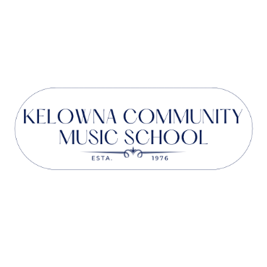
REGISTRATION 2022/23

Please complete all areas below.
Information will be forwarded to teachers and used for student records and school administration purposes.

